Sittingbourne Community College Archers
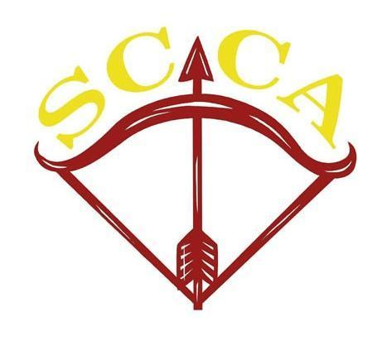

Entry Form
for the

SCCA and Cinque Ports Mobility & Healthcare Para Record Status Metric 720
& Festival

on

Saturday, 20th July 2024
at
Sittingbourne Community College,
Swanstree Avenue, Sittingbourne, Kent ME10 4NL

Directions:
Sittingbourne Community College is located just off the A2 on the Canterbury side of Sittingbourne.
If approaching from Canterbury, Swanstree Avenue is on the left-hand side of the road.

Record Status Round:
The rounds to be shot will be:
Metric 720

Entry Information

Eligibility: This tournament is open only to archers who are existing members of ArcheryGB or another World Archery member association.

Proof of membership may be requested at the tournament.
Record Status: This competition does have National Record Status.

Club: Because this event is organised by a county association, you must enter the tournament either as a member of your first-claim club (GNAS Law 20.b.v ) or as a Direct Member of KAA/other county/ArcheryGB (provided, of course, that you are).

Entry Fee: : £10.00 per Round

Cheques Payable to: SCCA Seniors BAC payment on Request

Closing Date for Entries: 13th July 2024 or until the list is full
No substitutions will be permitted and no refunds will be made after the closing date.

Entries : Adam Kenyon ✉11 Westlands Avenue, Sittingbourne, Kent ME10 1PG •adamkenyonarchery@outlook.com
Entry Form: Please complete the entry form in block capitals and return it with payment before the closing date. Entries will only be accepted with full payment.
If you require a target list / results sheet, please include a valid email address on the entry form.

Practice 10:00am
Sighters 11:00 a.m.

Judge: Debbie Horn and Warwick Davis
Gentleman Patron: To be confirmed
Lady Paramount: To be confirmed
Targets: Danage and Layered foam
Dress Code: ArcheryGB dress regulations as shown in the ‘Rules of Shooting’ will apply as if this were a National Record Status tournament, but traditional dark green / white or club shooting colours are preferred. Uniform can be worn
You are requested to observe the dress code until after the presentation of awards.
Awards: All awards are subject to entry and will be presented by the Lady Paramount as soon as possible after completion of shooting.Trophies will be awarded for a period of one year and will be dependent on the level of sponsorship received.

Lost Arrows: if you lose any arrows, you must find them before you leave the venue.
Disclaimer: Neither the Kent Archery Association nor the owners of the grounds can accept responsibility for loss or damage to equipment while on, entering or leaving the venue. No responsibility will be accepted for damage to arrows missing or passing through a target boss.
Photography: To comply with the ArcheryGB Policy for “Safeguarding Children, Young People & Vulnerable Adults”, any person wishing to pursue any form of photography for any purpose is required to report to the tournament organiser before starting and to comply with any conditions given.
Juniors: All competitors under the age of 18 must be supervised by a parent, guardian or other nominated responsible adult at all times.
Privacy Policy: Personal information supplied by you on the entry form will only be used for the purposes of this tournament, unless you indicate to the contrary.
No information will be disclosed to third parties, except as required by law.
Refreshments: Tea & coffee will be available free of charge to competitors and anyone who is there to assist competitors. Biscuits will be subject to suitable sponsorship.
Please ensure you bring a mug
Accommodation: If overnight accommodation is needed please contact the T/O for the names of possible, suitable establishments that have expressed support in the competition

The Venue

The SittingbourneSchool
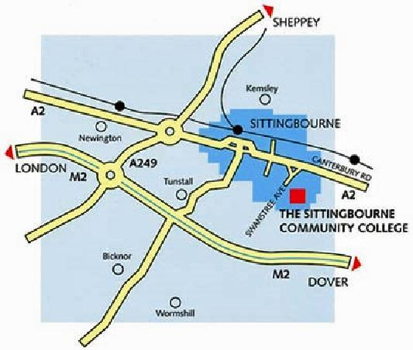
Postcode for satnavs: ME10 4NL

Acknowledgements
by kind permission The Sittingbourne School, home to one of the county's top school clubs, SCCA, and has supported this event previously.
Clickers Archery Ltd
63 Borrowdale Drive, Norwich, Norfolk, NR1 4NS
Phone: 01603 300490
Email: sales@clickersarchery.co.uk
Cinque Ports Mobility
125 Enbrook Valley, Folkestone, Kent CT20 3NE
Phone: 01303 850760
www.cinqueportsmobility.com
Logic Investments

Competition Categories and Classifications
Competitions:
SCCA wants to provide an enjoyable competitive environment for all para-archers. This event is therefore split into two separate competitions that will take place together at the same time – you need to specify on the entry form which one you want to enter:
Open Category
W1
Festival : This competition is for archers with any impairment wishing to take part in a fun event rather than a formal competition

Able bodied archers may also take part subject to space, but will not be eligible for awards.

Categories:
Please note that competition categories might be combined at the discretion of the tournament organiser, where the number of entries is particularly low.
Open Category: Archers with any type of disability, in separate categories for each of the specified bow-styles – bow-styles are as defined in the ArcheryGB Rules of Shooting.
W1: A single competition for archers, shooting any accepted bow-style. Note that compound bows in this category are limited to 35lb peek draw weight for ladies and 45lb for gentlemen; they cannot have either a peep-sight or scope, but can be shot with a release aid.
Visually Impaired: Archers with a B1 sight classification must wear blackouts from setting up any equipment until the end of the competition. .Archers in the VI 1 Shooting Category will aim using a tactile sighting device s.Archers in the VI 2/3 Shooting Category will aim/sight using a tactile sighting device complying with the relevant rules.
.

Simple Guide to Para-Archery Classifications:
Open: Athletes classified as open usually have an impairment in either the top or bottom half or one side of their bodies.This manifests itself in contrasting ways on the shooting line. Many archers use a wheelchair but are mobile in the top half of their bodies, There are two categories for open archers – one for those shooting recurves and one for those shooting compounds.The equipment rules for both are identical to able-bodied competition.Archers classified as W1 can choose to compete in the open events, should they reach the required performance level, as they exceed the required level of impairment
W1 :Athletes classified as W1 usually have an impairment in the top and bottom halves of their bodies, torso and at least three limbs. Stability is key to archery, and it is often the biggest challenge for athletes classified as W1.It’s for this reason that W1 archers are allowed to be strapped into their wheelchairs, while open classified athletes are not.The equipment rules are also unique for the W1 category. Archers may use either recurve or compound bows but must have a peak draw weight of no more than 45lbs. Peep sights, magnified lens and levelling bubbles are all banned. Some W1 athletes will also have an assistant to help them load the bow.

Entry Form
Where multiple choices are provided in the unshaded column, please indicate only one in each row, preferably by circling it. Age group must be based on your age on the date of the tournament.
Surname:
Forename(s):
Title: | Mrs. |  |  | Miss |  | Mr. |  |  |  | Mstr.
Address:
Telephone no.:
E-mail Address:
ArcheryGB member no.:
Club name:
Gender: | Lady |  |  |  |  |  |  | Gentleman
Age Group: | Senior |  |  |  |  |  |  | Junior DOB
Competition required: | Open W1 Festival
Bow Type: |  |  | Recurve |  | Recurve Barebow |  | Longbow |  | Compound |  | VI
Festival Distance:
Seated: | Yes |  |  |  |  |  |  | No
Competitor’s Signature: | ……………………………………………………………………………….
All competitors are required to accept the terms and conditions of entry. | Date:………………………………….  I certify I am a member of ArcheryGB or another World Archery Member Association.  I accept the terms of entry specified on the entry form and GNAS Rules of Shooting.
Cheque enclosed: | £10.00 per session (Payable to SCCA Seniors)  BAC payment on request
Signature of parent or guardian: | ……………………………………………………………………………….
Entries from juniors can only be accepted if signed here by a parent or guardian. | Date:………………………………….  I accept the terms of entry specified on the entry form.
Return to : Adam Kenyon ✉11 Westlands Avenue, Sittingbourne, Kent ME10 1PG ☎07504549375 Email to : adamkenyonarchery@outlook.com

