Kent Archery Association
www.kentarcheryassociation.co.uk
WA70m/50m with Head to Heads
World Record Status - Tier 2 Event
Sunday 9th June 2024
Venue: | Vigo Rugby Football Club, Swanswood, Harvel Road, Vigo Village DA13 0UA  (Sat Nav Co-Ordinates: 51 20’ 6” N / 0 22’ 4” E) (What3Words: ///itself.puff.almost)
Timings: | Registration: from 07:30 (Inspection thereafter)  Assembly: 08:30  Practice: 08:45 (2 ends of practice)  Match Play: from 13:30  (AGB states that all shooting equipment is subject to inspection)
Entry / Fees / Target Lists / Results: | Entry fee is £20.00 with all entries via the AGB Portal agb.sport80.com  Target Lists and Results will be published on Ianseo at www.ianseo.net
Opening / Closing Dates: | Opening Date: Sunday 7th April 2024 @ 18:00hrs  Closing Date: Monday 27th May 2024 @ 18:00hrs
Judges: | Hannah Brown (Chair of Judges), TBC (Director of Shooting), Erin Barkway (Line Judge), TBC (Line Judge), TBC (Line Judge)
Eligibility: | Only archers affiliated to Archery GB or another World Archery member association are eligible to shoot; proof of membership will be requested. Entries will be accepted in all recognised WA target bow styles plus English Longbow.  Because this event is organised by a County Association, then you must enter the tournament either as a member of your first-claim club (GNAS Law 20.b.v) or as a Direct Member of KAA / Other County / Archery GB (provided, of course, that you are).
Rounds: | The rounds to be shot are:  Round Distance Target Face  WA70m (Recurve / Longbow) 70m 122cm  WA50m (Compound) 50m 80cm – 6 zone  WA50m (Barebow) 50m 122cm  Followed by individual match play rounds. All rounds have World Record Status.  All age groups shoot as Seniors  It is expected the top 32 archers in each category will progress through to the match play rounds.
Timing: | 6 arrows in 4 minutes, controlled by Chronotir timing system. 3 arrows in 2 minutes for match play rounds, simultaneous shooting, also controlled by Chronotir timing system.
Targets & Target Faces: | All shooting will take place on TenZone layered foam bosses.  Target face sizes are as described above for the round being shot. A maximum of 4 archers per boss shot in double detail. Compound archers will have one face per archer (i.e. 4 faces per boss), all other archers will share the same face.
Lost Arrows: | As this is a multi-sports field, you must be aware of how many and what type of arrows you will be using at the event, and ensure you have all of these at the end.  All lost arrows must be found before you leave the field. Should you be unable to find your arrow before returning to the shooting line, inform the field party and judge who will place a marker on your target until your arrow is found.  Location may involve the use of metal detectors and or rakes. If it gets too dark to locate your arrow the venue will be notified of the loss along with contact details.
Awards: | Top 3 places for Recurve, Compound, Barebow and Longbow; Men and Women.  Awards will be presented as soon as possible after completion of shooting.
WA Target Awards: | Archers entering the WA70m (Recurve), WA50m (Barebow) and WA50m (Compound) rounds can claim a WA Target Award.  Competitors wishing to claim an award must do so before they leave the venue.
Food & Drink: | Unfortunately, food will not be available however hot drinks will be available in the clubhouse throughout the day.
Facilities: | Ladies and Gents toilets are available in the club house. Additionally, there is one wheelchair accessible toilet in the clubhouse.
Disabled Assistance: | If you require a space on the shooting line for a wheelchair / stool, please indicate this on your Sport:80 entry. Please contact the Tournament Organiser regarding any queries you may have and / or to provide any relevant additional information.
Smoking / Alcohol: | Smoking / Vaping is only permitted behind the tent line. No alcohol is allowed on the field.
Dogs: | Only registered Assistance Dogs are permitted on the field of play. All dogs must always be kept on a lead at all times.
Covid-19 Precautions: | Guidance and regulations applicable at the date of the tournament will apply.
Drug Testing: | This is a World Record Status tournament. Archers will be liable for drug testing, and competitors approached to give samples must comply. If they refuse, that refusal will be treated as a positive result. Entries from archers under the age of 18 must be signed by a parent/guardian to signify consent to their child being drug tested if approached.
Photography: | The Archery GB Protection of Children and Vulnerable Adults Policy requires that any person wishing to engage in any type of photography, filming or videoing at the tournament must register with the Tournament Organiser at the start of the event and comply with any conditions given.
Dress Code: | Dress regulations as shown in GNAS Rule 307 will apply. If you are unsure as to what this means please contact the tournament organiser. Archers are requested to observe the dress code until after the presentation of awards.
Disclaimer: | Neither Kent Archery Association nor the owners of the grounds can accept responsibility for loss or damage to equipment while on, entering or leaving the venue. No responsibility will be accepted for damage to arrows missing or passing through a target boss.
GDPR & Documentation: | By entering a Kent Archery Association Tournament, you agree that information may be collected and shared with tournament organisers, scoring systems, Archery GB and other competitors. Some information may also be published in documents or lists relating to the event to a schedule decided by the organisers. These include, but are not limited to: the entrant’s name, gender, bow style, age category, round, disability information, email addresses and/or contact numbers provided, club, county, region, country and any assigned codes for this information.
Parking: | There is plenty of free parking. Please park considerately and do not leave your car on any roadway.
Additional Note: | World Archery Rules of Shooting will be applicable on the day of the tournament.
Tournament Organiser: | Lewis Brown  Mobile: 07890 756983  Email: to@archerykent.org.uk

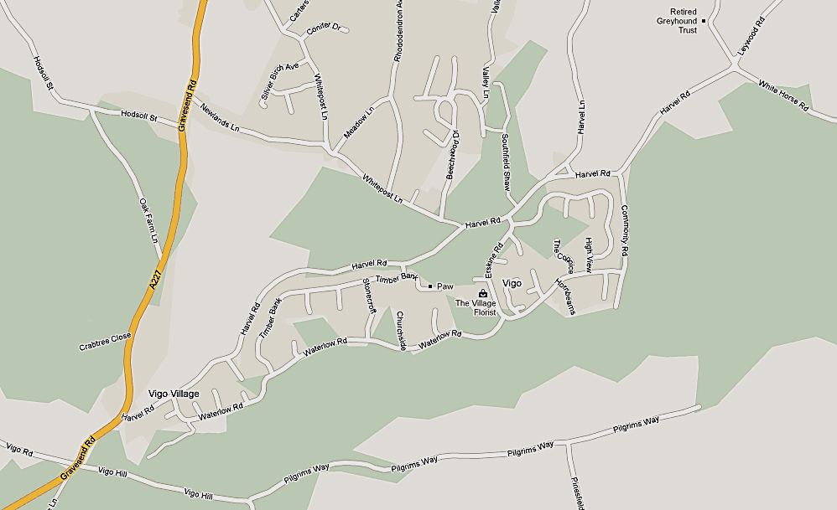

Directions: From M20 eastbound, leave at junction 2. From M20 westbound, join the M26 and leave immediately at junction 2A. From M26 east or westbound, leave at junction 2A. Then in each case follow signs for A227 towards Meopham and Gravesend. From the M2/A2 turn southwards onto the A227, & pass through Meopham. Vigo RFC is just east of Vigo Village. The entrance will be marked with archery target signs on the day.

